**Z**

**Can you match the picture to the word?**

[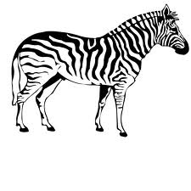](http://www.google.co.uk/imgres?q=zebra&hl=en&tbo=d&biw=1366&bih=673&tbm=isch&tbnid=1TsiD4-IL6JWHM:&imgrefurl=http://home-su-cool.blogspot.com/2011/03/z-zebra-plan.html&docid=bhy0jjNEwt0qCM&imgurl=http://2.bp.blogspot.com/-n0vVS4wACWc/TX1n5LzyWHI/AAAAAAAAIXw/29om9ATPjOU/s1600/zebra.jpg&w=700&h=700&ei=SVAGUZ6XNOaR0QWdvIC4AQ&zoom=1&iact=hc&vpx=927&vpy=227&dur=164&hovh=225&hovw=225&tx=123&ty=115&sig=100005348513402149479&page=2&tbnh=139&tbnw=138&start=19&ndsp=35&ved=1t:429,r:52,s:0,i:306)

**_ero**

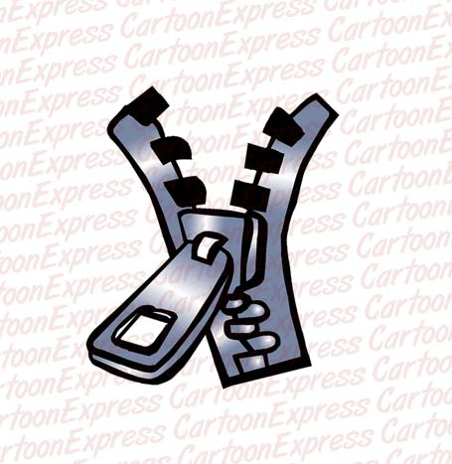

**_oo**

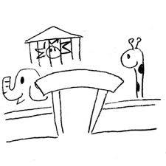

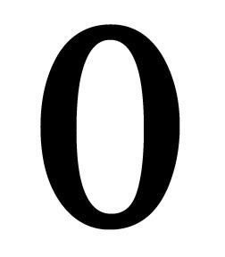**_ebra**

**_ip**