**x**

**Can you match the picture to the word?**

[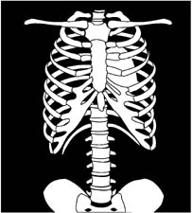](http://www.google.co.uk/url?sa=i&rct=j&q=xray+clipart&source=images&cd=&cad=rja&docid=Rz-QkSX4r-xcuM&tbnid=Fkjtgvr6cEJwcM:&ved=0CAUQjRw&url=http://www1.free-clipart.net/cgi-bin/clipart/directory.cgi?direct=clipart/Health_And_Medical/General&img=6&ei=4IMfUcv6KoSq4ASyq4HQDw&bvm=bv.42553238,d.bGE&psig=AFQjCNErq9kD1aaQlzyNaWScJ2H2EFIlpA&ust=1361106258112693)

**F o _**

[](http://www.google.co.uk/url?sa=i&rct=j&q=six+clipart&source=images&cd=&cad=rja&docid=2HuwO18hY25VDM&tbnid=KwEgwrdpca7MBM:&ved=0CAUQjRw&url=http://www.clker.com/clipart-six-1.html&ei=OoMfUf7yMcqF4ASj4IHQDg&bvm=bv.42553238,d.bGE&psig=AFQjCNFP2N6ZcmnNgm6CgI0IgkWZ1A201Q&ust=1361106082903684)

**B o _**

[](http://www.google.co.uk/url?sa=i&rct=j&q=box+clipart&source=images&cd=&cad=rja&docid=DfjY0DHICb_sXM&tbnid=tKpdLuB1r2anlM:&ved=0CAUQjRw&url=http://www.clker.com/clipart-3246.html&ei=qIMfUdqYHsnE4gTF24DoCw&bvm=bv.42553238,d.bGE&psig=AFQjCNHSVF1d3S9iek2CFb_ziPaz8uS-MQ&ust=1361106201744459)

**_ - r a y**

[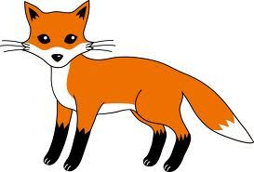](http://www.google.co.uk/url?sa=i&rct=j&q=fox+clipart&source=images&cd=&cad=rja&docid=gYkSR3UJWVe-kM&tbnid=MN_m2hfsgNRAPM:&ved=0CAUQjRw&url=http://www.sweetclipart.com/little-red-fox-1050&ei=b4MfUaCnEtSO4gTzx4GYAw&bvm=bv.42553238,d.bGE&psig=AFQjCNFO45sphFhRF5t6qaE2d1kP1O4U6A&ust=1361106147202517)

**S i _**