**‘V’ sound**

*Colour in the pictures which have a ‘v’ sound.*

[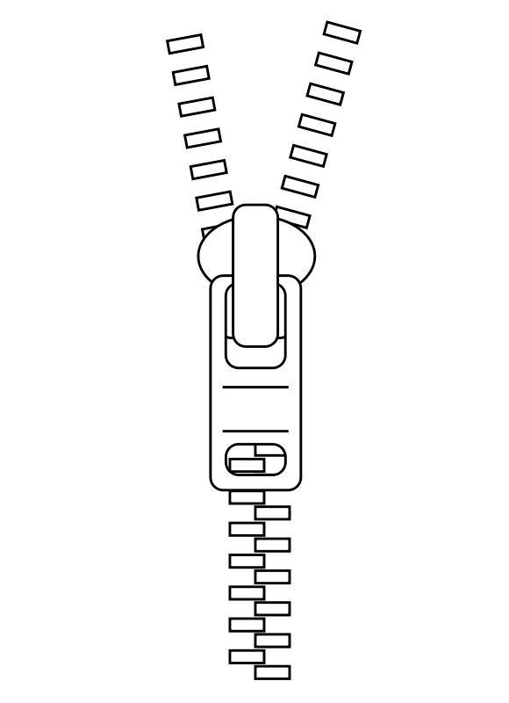](http://www.google.co.uk/url?sa=i&rct=j&q=zip+clipart&source=images&cd=&cad=rja&docid=dfQ0iDj613iv_M&tbnid=6KhyjBbN0ZtccM:&ved=0CAUQjRw&url=http://openclipart.org/detail/122785/zip-by-inkscapeforum.it&ei=Y34fUcSvBIjVtAa8xoCoBA&bvm=bv.42553238,d.bGE&psig=AFQjCNGpEhxpENhPE8DYGEOjQsAn8O9KyA&ust=1361104847024704) [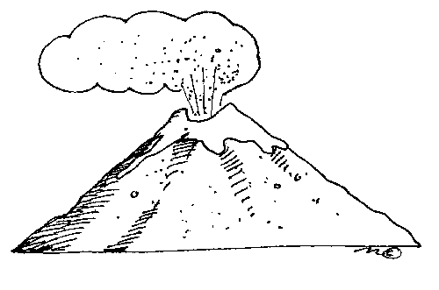](http://www.google.co.uk/url?sa=i&rct=j&q=volcano+clipart&source=images&cd=&cad=rja&docid=MLl7vOwLCYyvgM&tbnid=TrP-rmxAeJ-lwM:&ved=0CAUQjRw&url=http://school.discoveryeducation.com/clipart/clip/valcano1.html&ei=sX0fUd3NHIfYtQaK3oBw&bvm=bv.42553238,d.bGE&psig=AFQjCNFMvMso1qDbka3aUGjAkkJzgDqluQ&ust=1361104674894107)[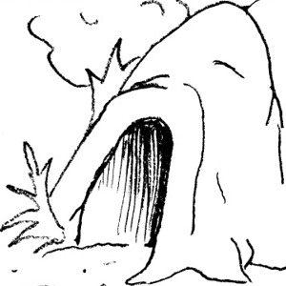](http://www.google.co.uk/url?sa=i&rct=j&q=cave+clipart&source=images&cd=&cad=rja&docid=STmCrK9gZecAEM&tbnid=bq5V5ofQRDn5oM:&ved=0CAUQjRw&url=http://www.funfonix.com/clipart4.php&ei=RH0fUbUHhsyzBqndgJAF&bvm=bv.42553238,d.bGE&psig=AFQjCNHR7p7pzNqiQSzTr6UT9kzNGs8adQ&ust=1361104564783346)[](http://www.google.co.uk/url?sa=i&rct=j&q=van+clipart&source=images&cd=&cad=rja&docid=pfdTLMV_OjgInM&tbnid=xGOnh9lUWizhnM:&ved=0CAUQjRw&url=http://www.clipartsfree.net/svg/3237-van-line-art-vector.html&ei=En0fUdCvFY_ltQamw4HADw&bvm=bv.42553238,d.bGE&psig=AFQjCNEhQ5Zg2sPsg4whpS36N-eyfTTyIw&ust=1361104519085699)[](http://www.google.co.uk/url?sa=i&rct=j&q=whale+clipart&source=images&cd=&cad=rja&docid=laMqkSHfiRYW-M&tbnid=pVP_tdcYWoXWeM:&ved=0CAUQjRw&url=http://www.tsl.state.tx.us/ld/projects/trc/2007/manual/pres_clipart.html&ei=-X0fUbTCFI_ltQamw4HADw&bvm=bv.42553238,d.bGE&psig=AFQjCNGnjDq7NvPDVBiciZ-hBEZuZq9T4w&ust=1361104750642754) [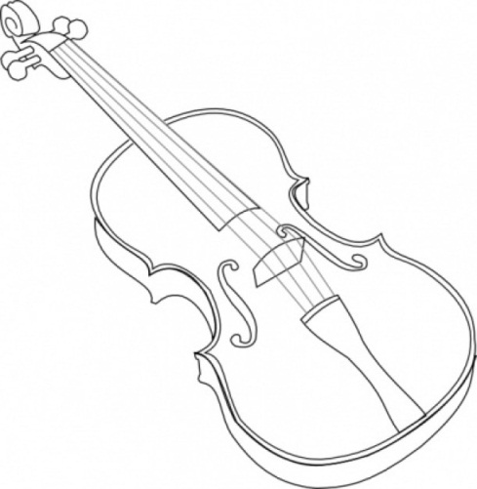](http://www.google.co.uk/url?sa=i&rct=j&q=violin+clipart&source=images&cd=&cad=rja&docid=lJJ7L-sNCNENYM&tbnid=HqGNGtUPa_IsRM:&ved=0CAUQjRw&url=http://www.freepik.com/free-vector/violin-clip-art_379181.htm&ei=f30fUffEDIHTtAbtwoGIDA&bvm=bv.42553238,d.bGE&psig=AFQjCNGo_hyG69N44vokkI9Bu7wTjqcZ8g&ust=1361104625019177) [](http://www.google.co.uk/url?sa=i&rct=j&q=five+clipart&source=images&cd=&cad=rja&docid=0uAdMANs8FI97M&tbnid=dhUZtOtgCDGN8M:&ved=0CAUQjRw&url=http://www.funfonix.com/clipart1.php&ei=4HwfUaO8JY_ltQamw4HADw&bvm=bv.42553238,d.bGE&psig=AFQjCNEQJg6YlOeBN8UmZULjZVf4DpeViw&ust=1361104469690627)