‘sh’ sound

[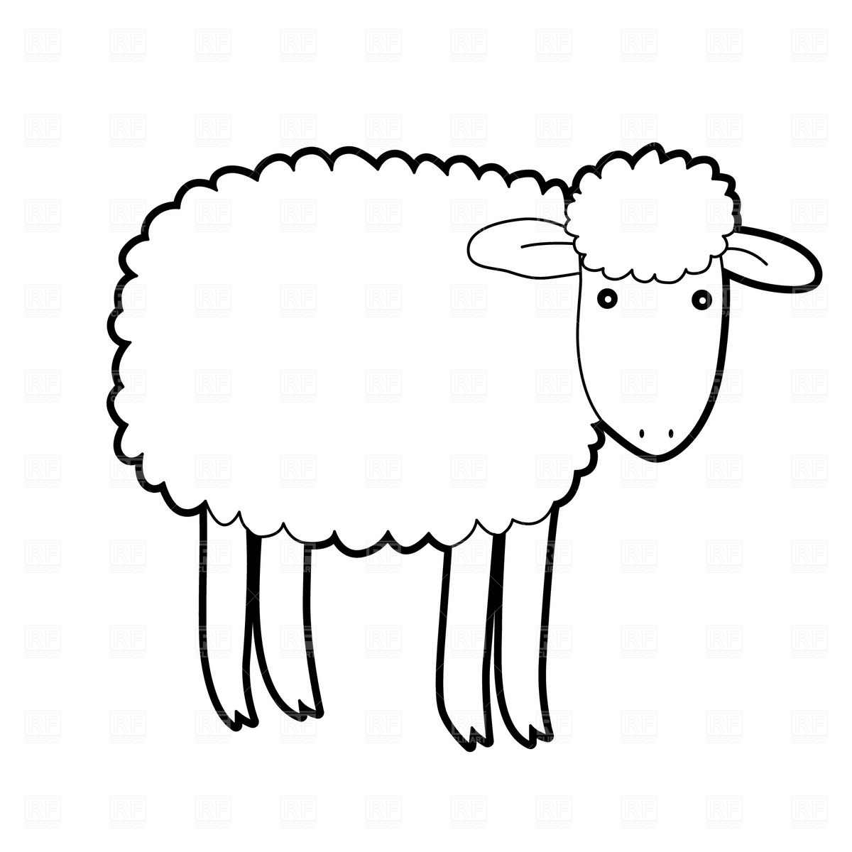](http://www.google.co.uk/url?sa=i&rct=j&q=sheep+outline&source=images&cd=&cad=rja&docid=lDAcIztwfJHO8M&tbnid=FiSkLVnvha9vSM:&ved=0CAUQjRw&url=http://www.picturesofsheep.com/archives/640&ei=coQfUfDlBOrV4gTkh4A4&bvm=bv.42553238,d.bGE&psig=AFQjCNGpNUNbhf9K-pBugGoLdIAmqT8WRQ&ust=1361106404083106)*Draw a different ‘sh’ word in each sheep and have a go at sounding out the word.*