‘Sh’ or ‘Ch’

*Circle the correct first sound.*

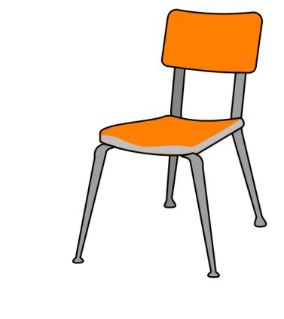[](http://www.google.co.uk/imgres?q=sheep+clip+art&hl=en&tbo=d&biw=1366&bih=673&tbm=isch&tbnid=VoLnroiQNSMNnM:&imgrefurl=http://www.clipartsfree.net/clipart/19357-cartoon-sheep-clipart.html&docid=MoKxKIREgmaEiM&imgurl=http://www.clipartsfree.net/vector/large/lemmling_Cartoon_sheep_Vector_Clipart.png&w=865&h=900&ei=EVwKUbjSBvGT0QXC2oHACQ&zoom=1&ved=1t:3588,r:12,s:0,i:181&iact=rc&dur=1032&sig=100005348513402149479&page=1&tbnh=177&tbnw=170&start=0&ndsp=19&tx=74&ty=56)[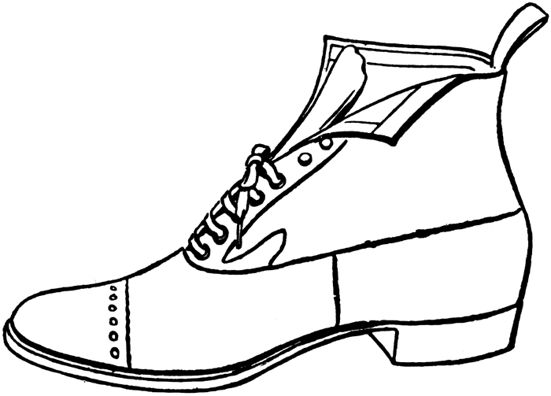](http://www.google.co.uk/url?sa=i&rct=j&q=shoe+clip+art&source=images&cd=&cad=rja&docid=H_5KBbrxpQ1LBM&tbnid=-Np-A9dockEi8M:&ved=0CAUQjRw&url=http://bestclipartblog.com/26-shoe-clip-art.html/shoe-clip-art-10&ei=1lsKUfXjH8ip0QXfu4GYDw&bvm=bv.41642243,d.d2k&psig=AFQjCNF-rja-dkxA0b3FLn_vTV1-sAPD5g&ust=1359719722278686)[](http://www.google.co.uk/url?sa=i&rct=j&q=shark+clip+art&source=images&cd=&cad=rja&docid=Z_YCFtJasAwGtM&tbnid=hr_b17sWDJ_r4M:&ved=0CAUQjRw&url=http://clipartstockphoto.com/shark-clipart&ei=a1sKUcThOsrQ0QWhloGABQ&bvm=bv.41642243,d.d2k&psig=AFQjCNHtI6iR5nOkZAT6WYaIZdWkJYRg4A&ust=1359719625739673)[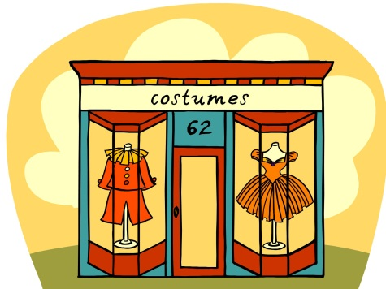](http://www.google.co.uk/url?sa=i&rct=j&q=shop+clip+art&source=images&cd=&cad=rja&docid=auHYMoJpZQZUvM&tbnid=O3i1v_gAAGd3oM:&ved=0CAUQjRw&url=http://myfirstworld.com/page20415.html&ei=5FoKUbuUJaLV0QXF6YDwBw&bvm=bv.41642243,d.d2k&psig=AFQjCNEShYYrCUwX2pWFFKKKH-bNpJxV4w&ust=1359719449058389)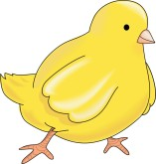[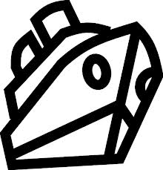](http://www.google.co.uk/url?sa=i&rct=j&q=ship+clip+art&source=images&cd=&cad=rja&docid=1oZzq_zNxLOcUM&tbnid=swDttC7eVKolwM:&ved=0CAUQjRw&url=http://www.aperfectworld.org/transportation.html&ei=Z1kKUdLjN_C00QWM-IG4Dw&bvm=bv.41642243,d.d2k&psig=AFQjCNGdjOAMw2X-hD4xeXWol0kKkGl9Uw&ust=1359719126498167)

**Sh Ch**

**Sh Ch**

**Sh Ch**

**Sh Ch**

**Sh Ch**

**Sh Ch**

**Sh Ch**

**Sh Ch**

**Sh Ch**