*Can you draw a picture to go with the word?*

[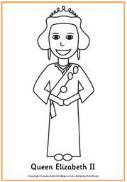](http://www.google.co.uk/imgres?q=queen+elizabeth+clipart&hl=en&sa=X&tbo=d&biw=1366&bih=673&tbm=isch&tbnid=pwjuOtR98VxtEM:&imgrefurl=http://www.activityvillage.co.uk/diamond_jubilee.htm&docid=JycB7Xcyr9P_KM&imgurl=http://www.activityvillage.co.uk/queen_elizabeth_ii_colouring_page.jpg&w=224&h=320&ei=21UGUdvzJ4Wk0AWy-oG4Ag&zoom=1&iact=hc&vpx=536&vpy=93&dur=784&hovh=256&hovw=179&tx=132&ty=127&sig=100005348513402149479&page=1&tbnh=138&tbnw=97&start=0&ndsp=39&ved=1t:429,r:4,s:0,i:91)

_ _ iet

_ _ ack

_ _ een

_ _ een

_ _ ick

_ _ estion