*Can you draw a picture to go with the word?*

[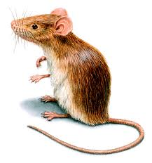](http://www.google.co.uk/url?sa=i&rct=j&q=mouse&source=images&cd=&cad=rja&docid=r5DGjVJS5hrcVM&tbnid=1Jyii67p4HQ5iM:&ved=0CAUQjRw&url=http://www.orkin.com/rodents/house-mouse/the-common-house-mouse/&ei=woUfUa3VLeam4gSysIHgBg&bvm=bv.42553238,d.bGE&psig=AFQjCNGmWmBMD6Z7kecEu4A3-_ibir5rig&ust=1361106744283749)

H _ _ s e

P _ _ c h

_ _ c h

M _ _ se

C l _ _ d