‘or’ sound

If you can hear the ‘or’ sound draw a line to the middle.

[](http://www.google.co.uk/url?sa=i&rct=j&q=fork+clipart&source=images&cd=&cad=rja&docid=VcHjwfiIvBzzlM&tbnid=xvow-CdQVsOGkM:&ved=0CAUQjRw&url=http://www.clker.com/clipart-fork.html&ei=QnsfUcfcPMWstAaVwYGQAw&bvm=bv.42553238,d.bGE&psig=AFQjCNH7hTy7kciilnFdpUFXHL5ojJaBgg&ust=1361104055761556)[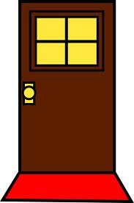](http://www.google.co.uk/url?sa=i&rct=j&q=door+clipart&source=images&cd=&cad=rja&docid=npIiVryzy67K2M&tbnid=Oc_2lSEe1LI79M:&ved=0CAUQjRw&url=http://sweetclipart.com/simple-brown-door-design-290&ei=73kfUcvoEs3htQaR4oCYCw&bvm=bv.42553238,d.bGE&psig=AFQjCNEhgVWD8JEGyV-lx2N_RFMxq3DQaw&ust=1361103716729497)

do_ _ f _ _ k

[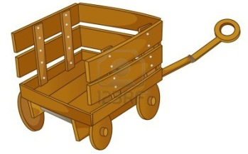](http://www.google.co.uk/url?sa=i&rct=j&q=cart+clipart&source=images&cd=&cad=rja&docid=013k7mkqd_MoaM&tbnid=PoJ9_dOxDGedqM:&ved=0CAUQjRw&url=http://www.123rf.com/photo_13120988_clipart-style-cartoon-of-a-cart.html&ei=1HsfUcH_L8fasgbc54DQDw&bvm=bv.42553238,d.bGE&psig=AFQjCNH4X4954_Ezqh2iku1TriYDdjELlg&ust=1361104201435521)[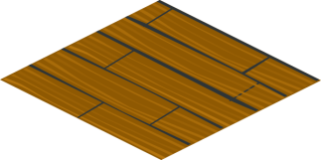](http://www.google.co.uk/url?sa=i&rct=j&q=floor+clipart&source=images&cd=&cad=rja&docid=crA_-GOYoqONcM&tbnid=eGkSGqGcTXmHlM:&ved=0CAUQjRw&url=http://www.clker.com/clipart-25283.html&ei=SXofUc6wIsrMtQbJ2IHIBQ&bvm=bv.42553238,d.bGE&psig=AFQjCNGPuiRkrQGSPQcPfwnVCDdOxQLRGg&ust=1361103796209321)

[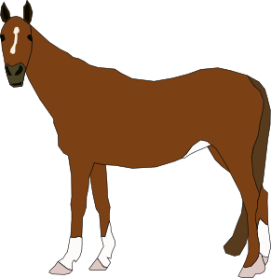](http://www.google.co.uk/url?sa=i&rct=j&q=horse+clipart&source=images&cd=&cad=rja&docid=biDAZxORK6iXfM&tbnid=a8wR7_WzMyq9uM:&ved=0CAUQjRw&url=http://www.clker.com/clipart-10982.html&ei=kXsfUcqkIcTLtAaNioCIDg&bvm=bv.42553238,d.bGE&psig=AFQjCNHK0IvrwCh61Co254qRnN_amRi17A&ust=1361104131830740)[](http://www.google.co.uk/url?sa=i&rct=j&q=core+clipart&source=images&cd=&cad=rja&docid=_iUXTgo5OJ7azM&tbnid=AOmd-waYq9IxWM:&ved=0CAUQjRw&url=http://www.clker.com/clipart-3985.html&ei=7HofUdD9BcjItQa9wYHoDQ&bvm=bv.42553238,d.bGE&psig=AFQjCNEB9XcWw3ie7baH7UdOIKZqTLaPYw&ust=1361103966893373)

f l o _ _ c _ _ t