‘oa’ sound
Can you carefully sound out the words below?
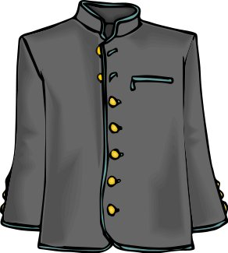  _ _ _ _ | 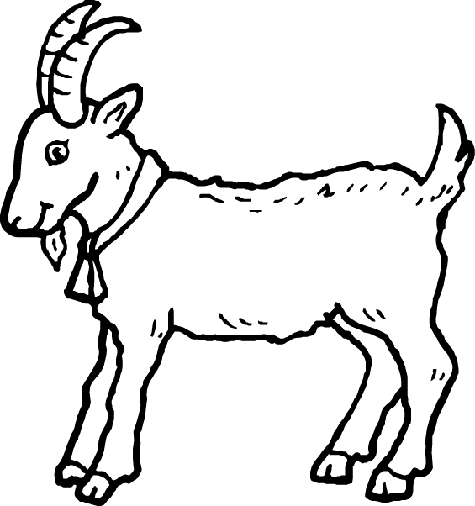  _ _ _ _ | 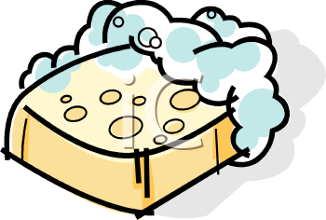  _ _ _ _
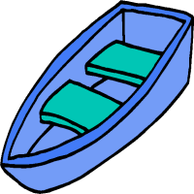  _ _ _ _ | 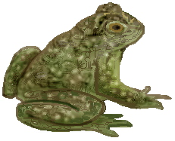  _ _ _ _ | 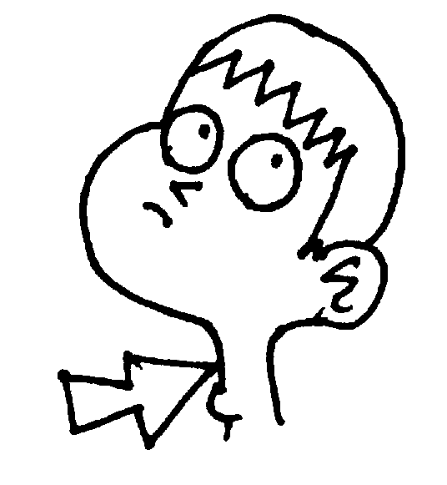  _ _ _ _ _ _
Challenge
Can you think of any more ‘oa’ words?

