‘nk’ sound

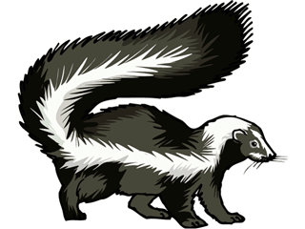[](javascript:edit(213812))[](http://www.google.co.uk/imgres?q=pink+clipart&num=10&hl=en&tbo=d&biw=1366&bih=673&tbm=isch&tbnid=Acr_3caof51GIM:&imgrefurl=http://www.clker.com/clipart-pink-3.html&docid=hOR5AvSifE50CM&imgurl=http://www.clker.com/cliparts/c/V/M/r/m/h/pink-md.png&w=299&h=282&ei=8V0GUf72Meub1AXOzoAo&zoom=1&iact=hc&vpx=766&vpy=158&dur=274&hovh=218&hovw=231&tx=143&ty=119&sig=100005348513402149479&page=1&tbnh=148&tbnw=157&start=0&ndsp=26&ved=1t:429,r:5,s:0,i:98)If you can hear the ‘nk’ sound draw a line to the middle.

Sku_ _ Si _ _

[](http://www.google.co.uk/imgres?q=king+clipart&hl=en&tbo=d&biw=1366&bih=673&tbm=isch&tbnid=wApeK1DqyfoGMM:&imgrefurl=http://art-dbase.net/search.php?id=17185&docid=BogJRERzkvzYQM&imgurl=http://2.bp.blogspot.com/-p4R8dNPRrk0/T6lj0nE70DI/AAAAAAAAAHg/Dcd-cL6n_b8/s1600/king_01_clip.gif&w=516&h=700&ei=W14GUfqbL8Wn0QWky4HICw&zoom=1&iact=hc&vpx=103&vpy=128&dur=594&hovh=262&hovw=193&tx=127&ty=144&sig=100005348513402149479&page=1&tbnh=141&tbnw=104&start=0&ndsp=30&ved=1t:429,r:1,s:0,i:96)



Ri_ _ Pi _ _