‘J’ sound

[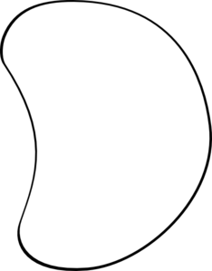](http://www.google.co.uk/url?sa=i&rct=j&q=jelly+bean+outline+clipart&source=images&cd=&cad=rja&docid=I6mWn0cxoyVQIM&tbnid=OMBMpQHwdU8B2M:&ved=0CAUQjRw&url=http://www.clker.com/clipart-white-jellybean.html&ei=1FYeUbzRMsvIsgajqoBQ&bvm=bv.42553238,d.Yms&psig=AFQjCNH-0C8iWB8tG7DME8ciZ1PYOfPQig&ust=1361029182638729)*Draw a different ‘j’ word in each jelly bean and have a go at sounding out the word.*