‘ie’ and ‘i-e’ sound

*Can you match the word to the picture?*

[](http://www.google.co.uk/url?sa=i&rct=j&q=tie+clipart&source=images&cd=&cad=rja&docid=NDBx54EHWtefBM&tbnid=syCZn_0DMi_kkM:&ved=0CAUQjRw&url=http://www.clipsahoy.com/clothing/ties/ties1.htm&ei=-3MfUc2sJqiR4ASYvoG4CQ&bvm=bv.42553238,d.bGE&psig=AFQjCNHoOGzZ-t9aZRj33YqO6WfL7Lli5Q&ust=1361102185011366)

[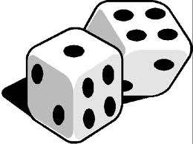](http://www.google.co.uk/url?sa=i&rct=j&q=dice+clipart&source=images&cd=&cad=rja&docid=dMX2v77pLcgQWM&tbnid=UOK3bI-yB_RuyM:&ved=0CAUQjRw&url=http://nicecliparts.com/images-Dice.php&ei=InYfUZTdCoi14AT1hYHYAg&bvm=bv.42553238,d.bGE&psig=AFQjCNEpmFE-5ubmwkVpt1dEOndkZxxZUg&ust=1361102738284185)[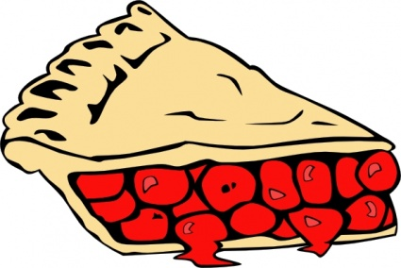](http://www.google.co.uk/url?sa=i&rct=j&q=pie+clipart&source=images&cd=&cad=rja&docid=3iSmta7JInn1IM&tbnid=sczk6Krga8CVBM:&ved=0CAUQjRw&url=http://livetips.info/apple-pie-cartoon/&ei=qXMfUdCUEOnx4QTx5IGgAw&bvm=bv.42553238,d.bGE&psig=AFQjCNHbW_GoPb4V8Wcuqwg6tC4Bwf983g&ust=1361102109777225)

[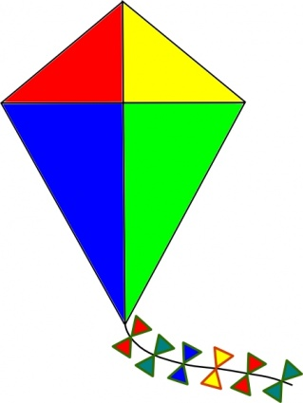](http://www.google.co.uk/url?sa=i&rct=j&q=kite+clipart&source=images&cd=&cad=rja&docid=fcIT86aTQ9mKeM&tbnid=H5Ub7iuJLUMDsM:&ved=0CAUQjRw&url=http://www.easyvectors.com/browse/other/kite-clip-art&ei=rXUfUczjHKqG4ATy9oHwDg&bvm=bv.42553238,d.bGE&psig=AFQjCNEvQlYdIHp3ehh105-QjVDKw_jNtg&ust=1361102598341035)[](http://www.google.co.uk/url?sa=i&rct=j&q=bite+clipart&source=images&cd=&cad=rja&docid=HshoUeVkjeIfHM&tbnid=vgAajJlue05HrM:&ved=0CAUQjRw&url=http://www.examiner.com/article/eat-mindfully-to-avoid-holiday-weight-gain-part-iii-the-lost-art-of-chewing&ei=XnUfUai-F8bE4gT4tIHQCg&bvm=bv.42553238,d.bGE&psig=AFQjCNH2aR3_hcrOlctg_eqGm5W5MwKhpQ&ust=1361102525792812)[](http://www.google.co.uk/url?sa=i&rct=j&q=die+clipart&source=images&cd=&cad=rja&docid=oYSlRkJep93gQM&tbnid=nMqn2nUXsHH_dM:&ved=0CAUQjRw&url=http://www.tn-atheist.com/2009/03/atheist-explains-what-happens-when-we-die/&ei=23QfUc7PLqqA4gSYwYCADw&bvm=bv.42553238,d.bGE&psig=AFQjCNG1fiw8xE7LrtHJfBkuf6_uFSah0A&ust=1361102406548349)

Kite pie bite

tie dice die