‘ee’ sound

[](http://www.google.co.uk/url?sa=i&rct=j&q=tree+outline&source=images&cd=&cad=rja&docid=40fbcX0UMIN0oM&tbnid=YMb70Gd3SiG3QM:&ved=0CAUQjRw&url=http://www.brilliantbeginningspreschoolutah.com/2011/03/t-is-for-tissue-paper-trees.html&ei=8HYfUYKZEaqo4gT2jIHwAg&bvm=bv.42553238,d.bGE&psig=AFQjCNEBGRUYYE8lxTyKv7c-OM0dH1zckQ&ust=1361102948135225)*Can you sound out the words then think of one of your own?*

[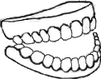](http://www.google.co.uk/url?sa=i&rct=j&q=TEETH+outline&source=images&cd=&cad=rja&docid=4_zAXX6v3ROBHM&tbnid=0-Mpa-rTcUVgHM:&ved=0CAUQjRw&url=http://www.talkingman.net/&ei=AHgfUfGTCOX54QT77ICYBQ&bvm=bv.42553238,d.bGE&psig=AFQjCNFFtzsYIzr2vVZZ4IXmOMtXRGeLGw&ust=1361103172912392)[](http://www.google.co.uk/url?sa=i&rct=j&q=three+outline&source=images&cd=&cad=rja&docid=lHBoHY-xBKF2fM&tbnid=cpunGhfhySsKSM:&ved=0CAUQjRw&url=http://www.spreadshirt.net/comic-number-3-outline-1c-kids-shirts-C4408A17168328&ei=j3cfUZDXC-X54QT77ICYBQ&bvm=bv.42553238,d.bGE&psig=AFQjCNEdm-UUVGEab8e9BKU1HNXr7E5sKQ&ust=1361103096429286)

_ _ _ _ _ _ _ _ _ _ _ _ _ _

[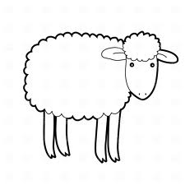](http://www.google.co.uk/url?sa=i&rct=j&q=sheep+outline&source=images&cd=&cad=rja&docid=lDAcIztwfJHO8M&tbnid=FiSkLVnvha9vSM:&ved=0CAUQjRw&url=http://www.picturesofsheep.com/archives/640&ei=hHgfUamnPML-4QT83oCICQ&bvm=bv.42553238,d.bGE&psig=AFQjCNGSOcwhATX_GvaKrOYCBkvkn-hQVQ&ust=1361103354868777)[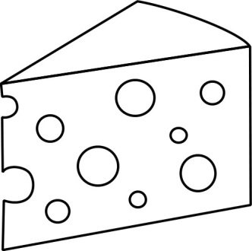](http://www.google.co.uk/url?sa=i&rct=j&q=cheese+outline&source=images&cd=&cad=rja&docid=Jz2JwVCO6WcWFM&tbnid=CJUPCvE-XjSplM:&ved=0CAUQjRw&url=http://www.art-saloon.ru/language.aspx?ReturnTo=/ru/comment.aspx?ItemID=4002&ei=M3cfUYTvHqOD4gT8i4DoBQ&bvm=bv.42553238,d.bGE&psig=AFQjCNGTFcctv-CA1EkN_tmGIh8E3An8Yw&ust=1361103011651936)

_ _ _ _ _ e _ _ _ _ _